Assignment and In-class exercises submission using Google Colab and GitHub
We will use Google Colab + GitHub for in-class exercises and assignment submission. Please follow the following instructions to create a repository for this course and connect it with Google Colab.
Step 1: Create a new account on GitHub or sign in any existing account: https://github.com/
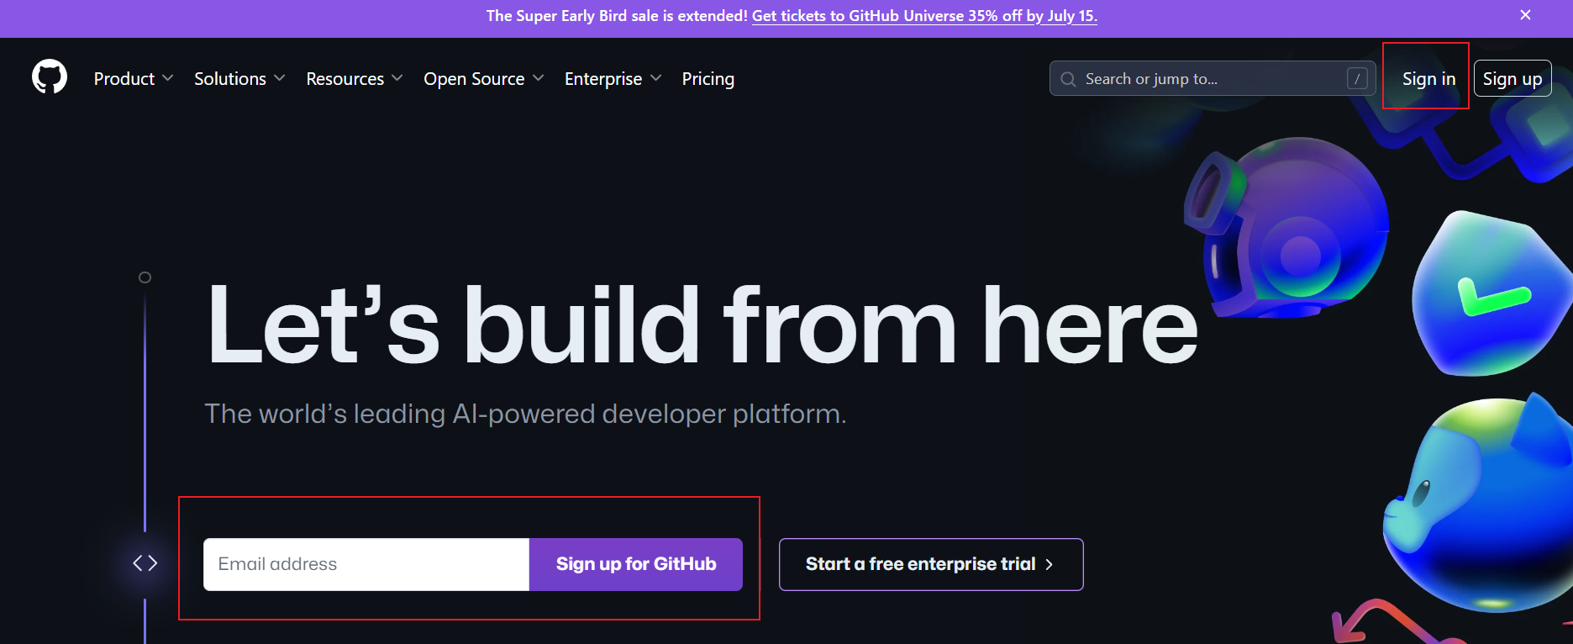
Step 2: Create a new repository for this course with a common convention for naming as follows: your firstname_INFO5731_Fall2024 (your first name_INFO5731_Fall2024)
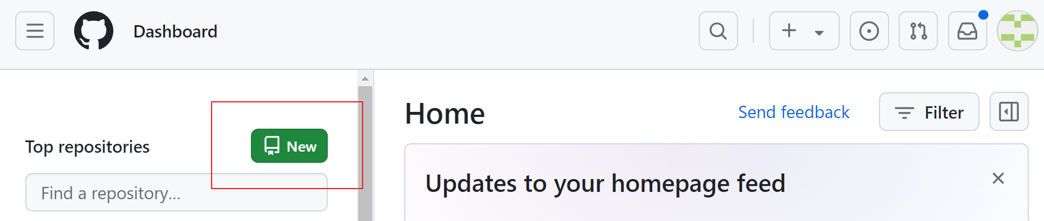
Click “New” button on the left side of the window, and you will see the following screenshot, fill the information, and click the “create repository” button.
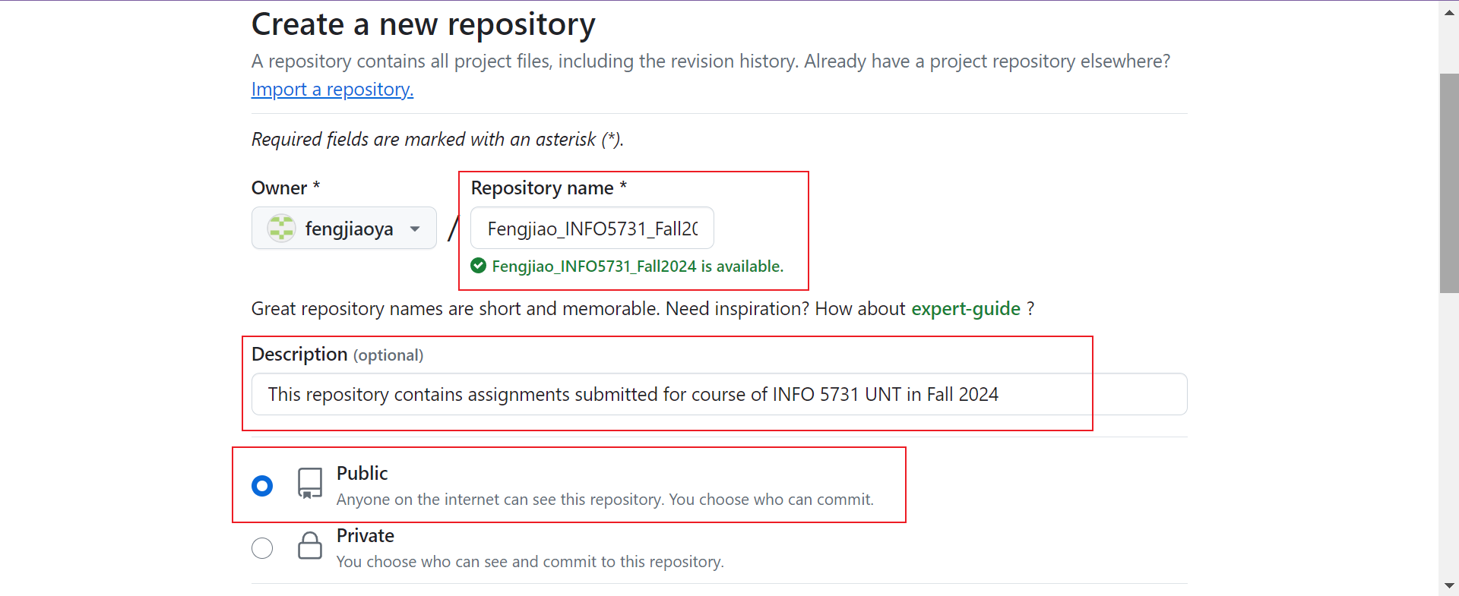
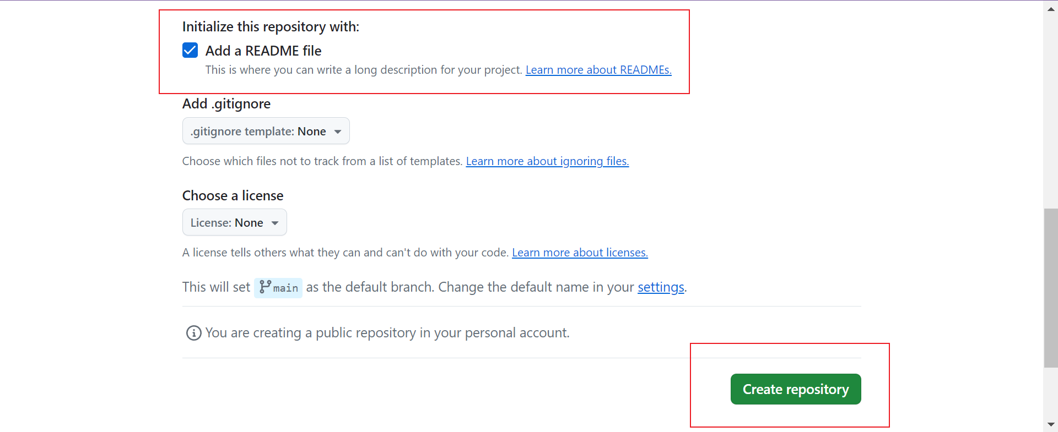

Now you have successfully created a repository for this course in your account, as shown in the following screenshot:
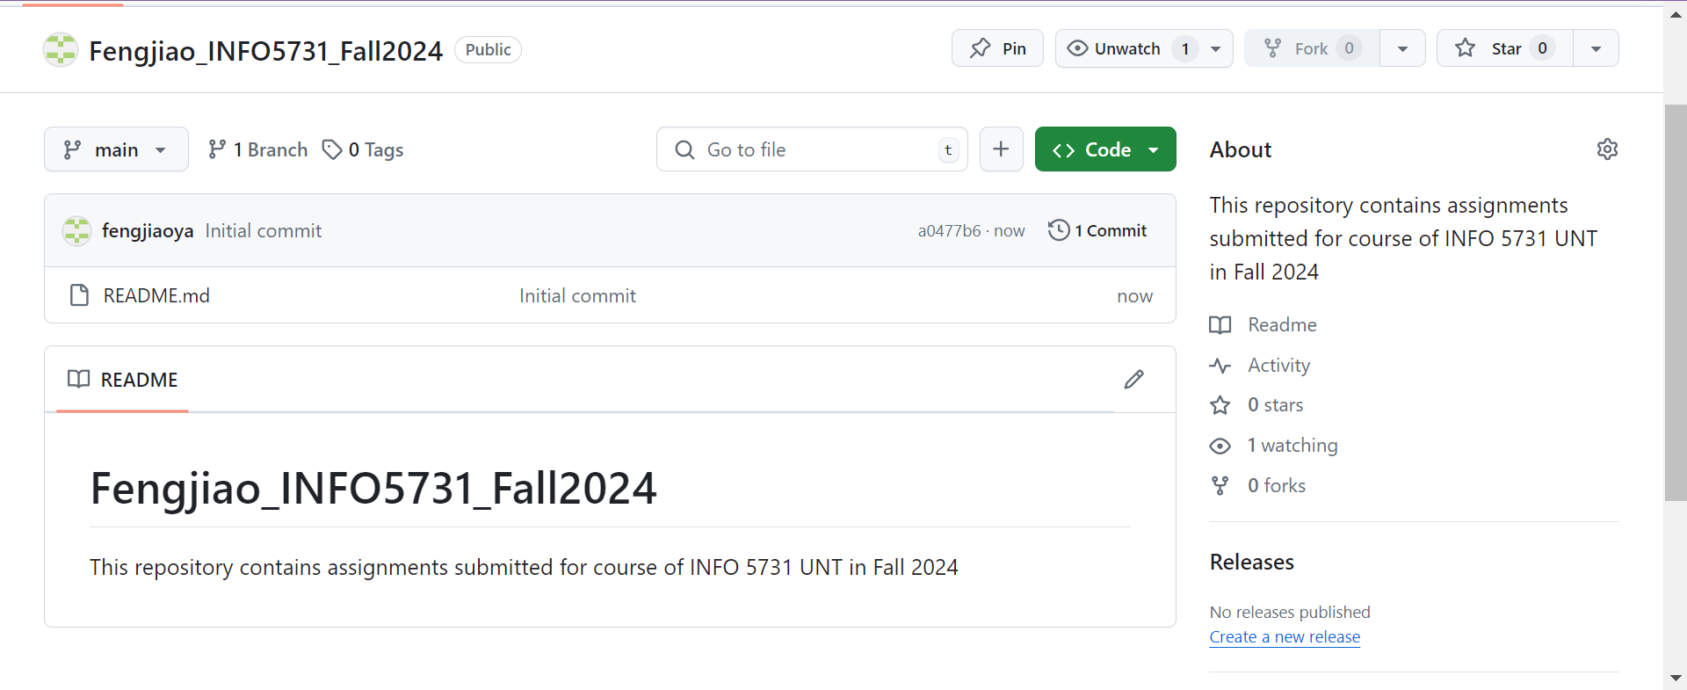

Step 3: Login Google Colab with your Google account by clicking this link:
https://colab.research.google.com/notebooks/welcome.ipynb#

Step 4: Create the first “.ipynb” file by click “File” to choose “New notebook in drive” to write your python code:
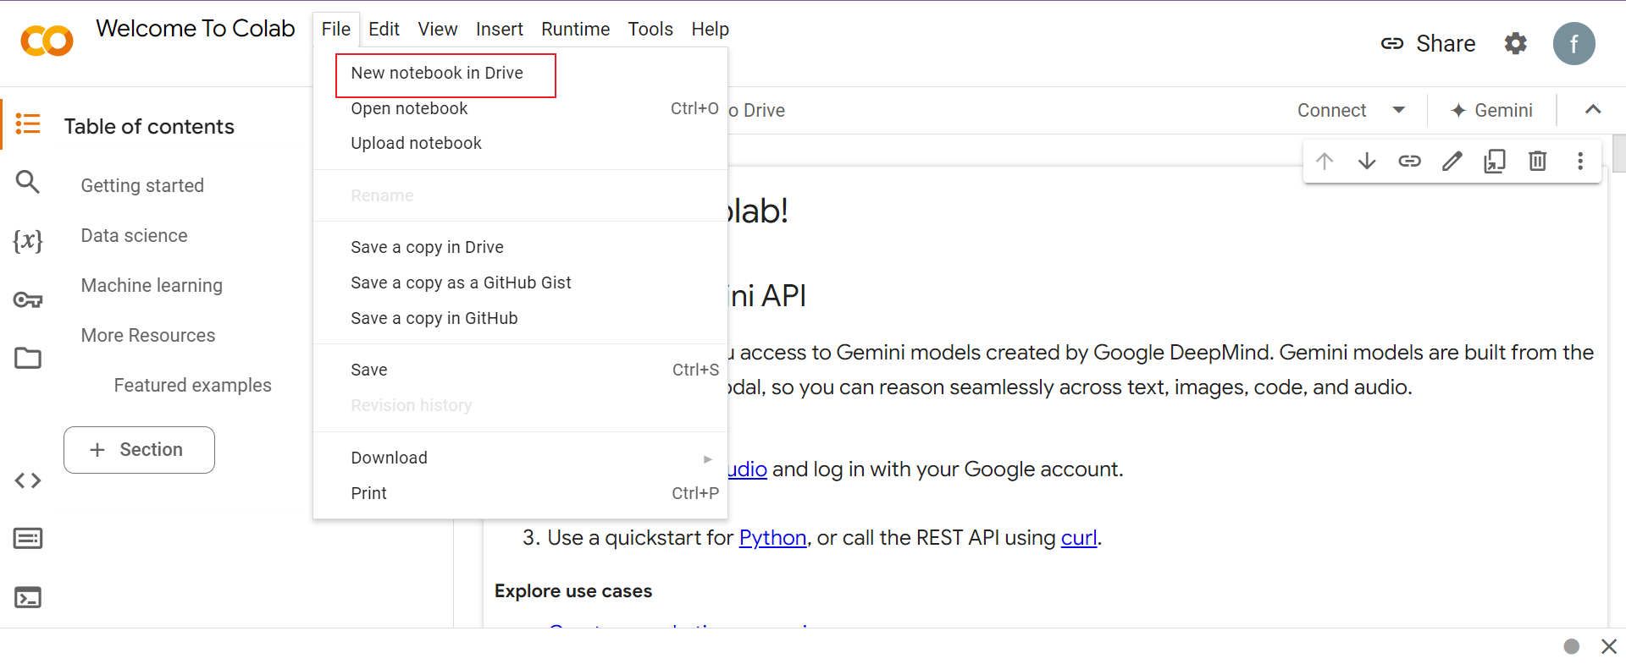
Rename the file, for example, “in_class_exercise_01”:
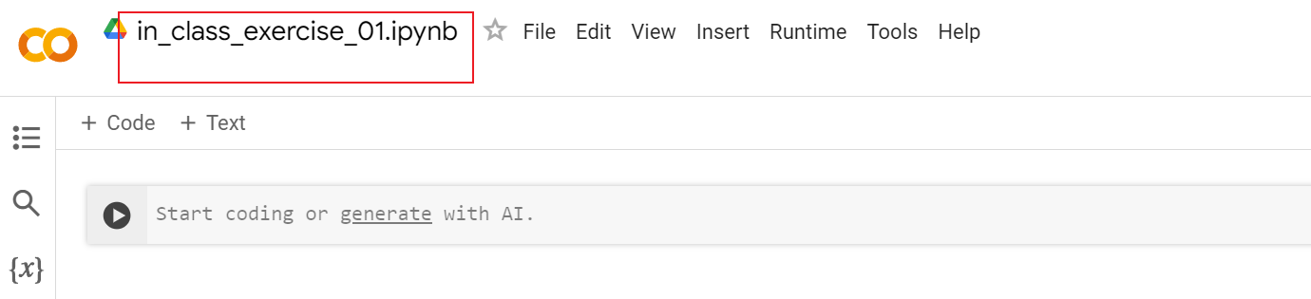
Then add Code module by clicking “+ Code” button or add Text module by clicking “+ Text” button.
- Look at the following example:
Click “Run” under “Runtime” to run your code. Remember to save you code (by using Ctrl+S keyboard shortcut)
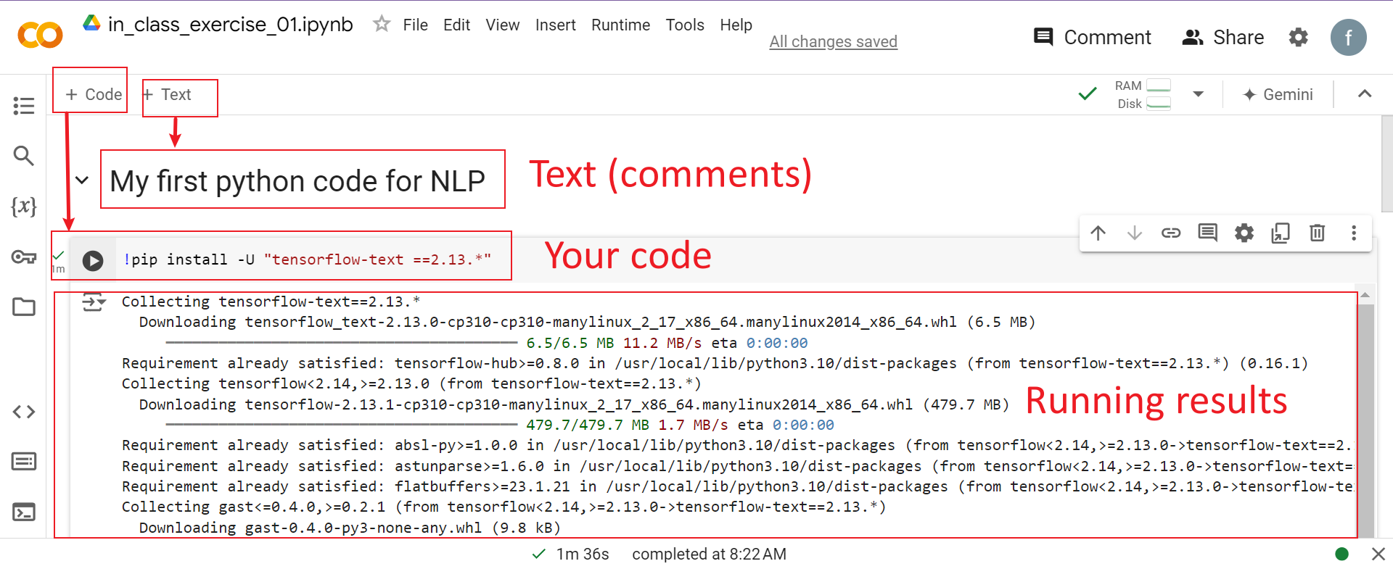

Step 5: Save your code in the repository you have just created on GitHub.
Click “Save a copy in GitHub” under “File”, as shown below:
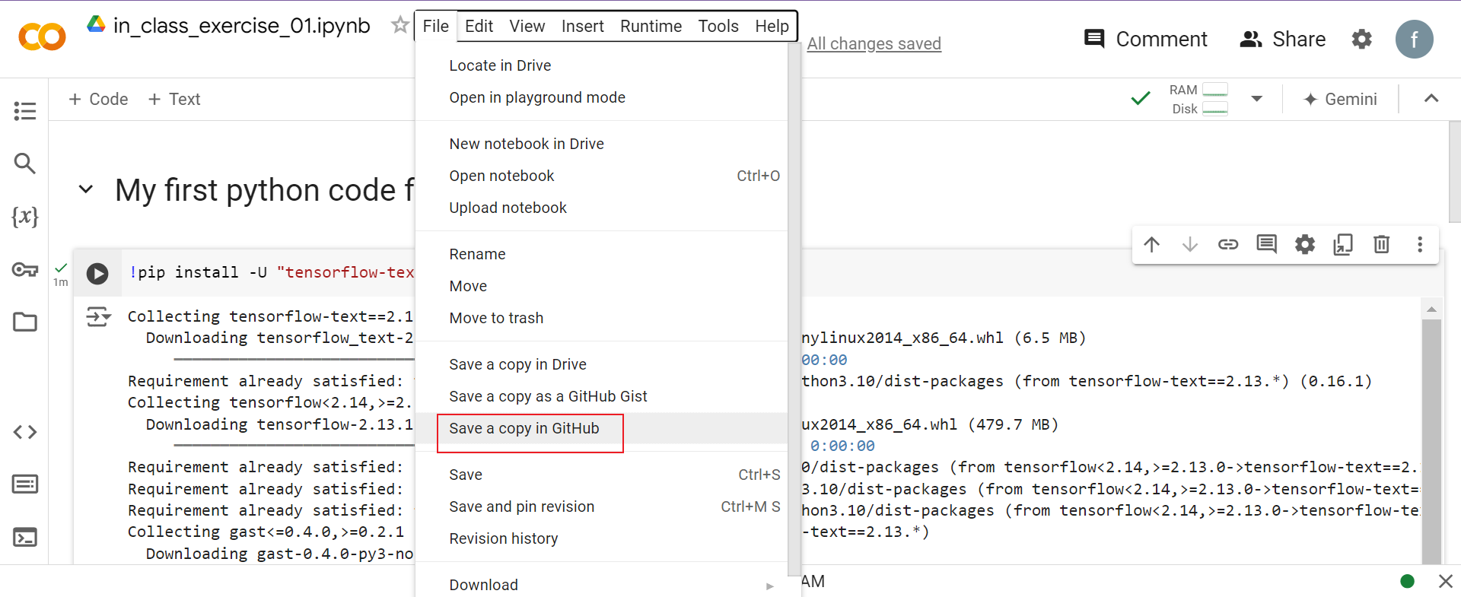
Select the repository you have just created for the course, and create a file path to your located file, as shown in the following screenshot:
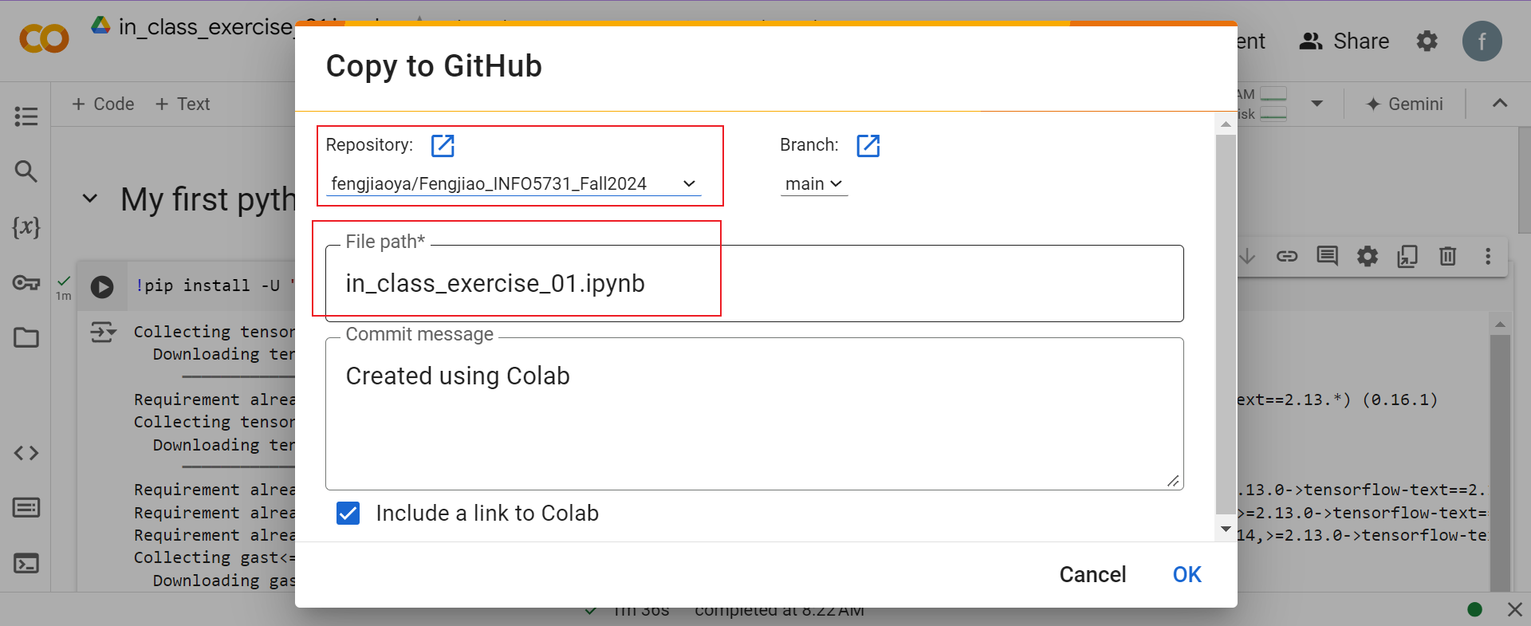
Now your code has been saved successfully on GitHub:
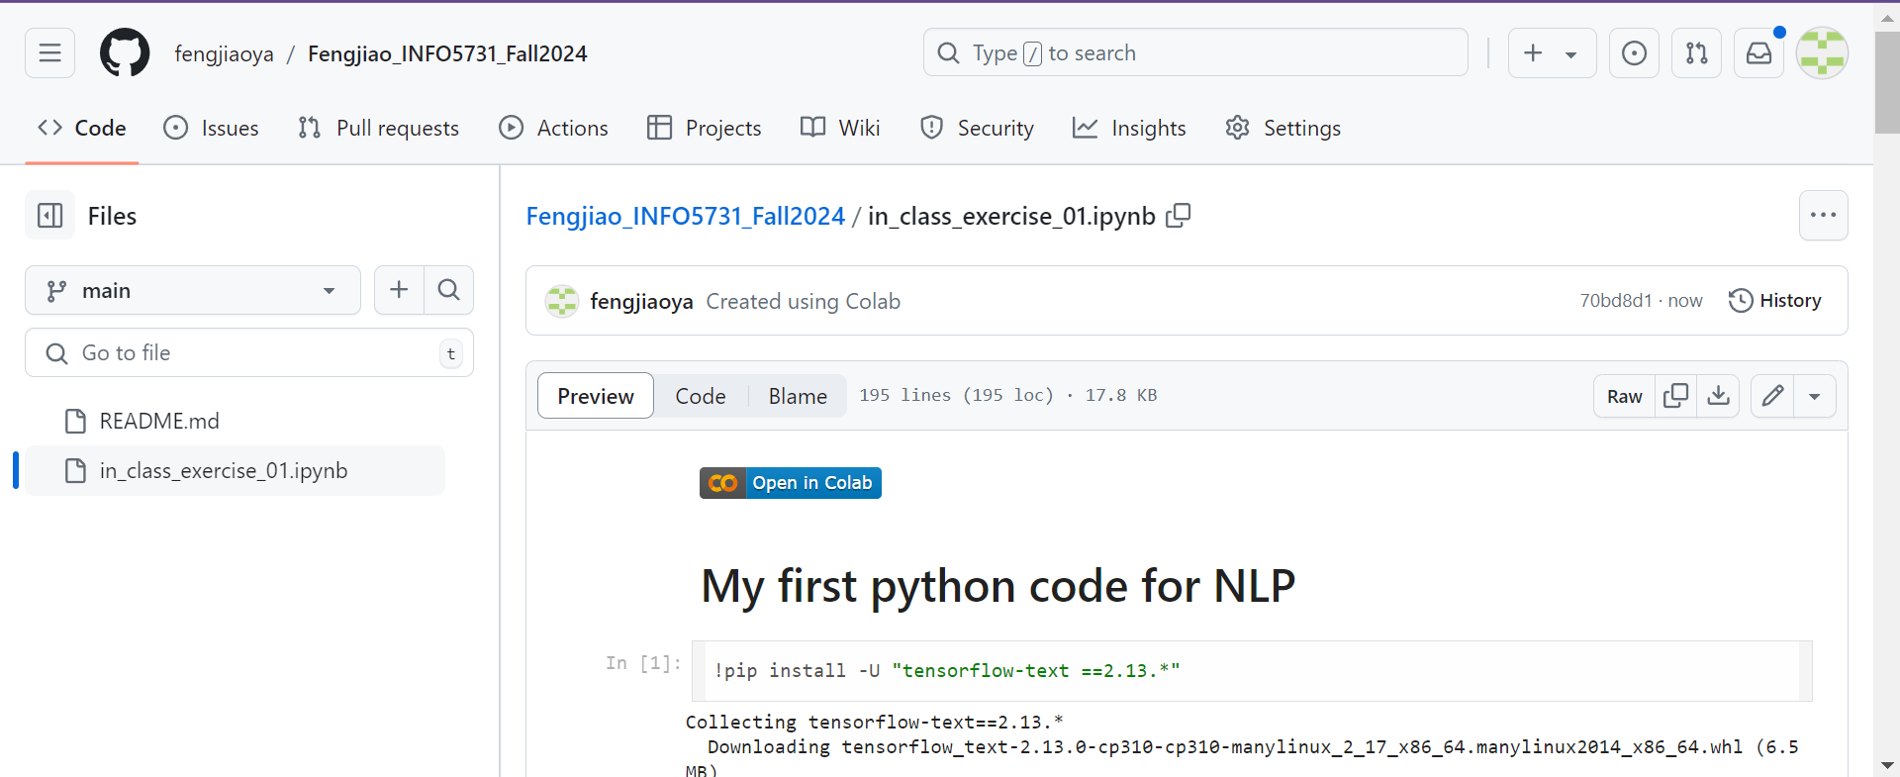
Step 6: Copy the link for submitting as your assignment, as shown in the following screenshot:
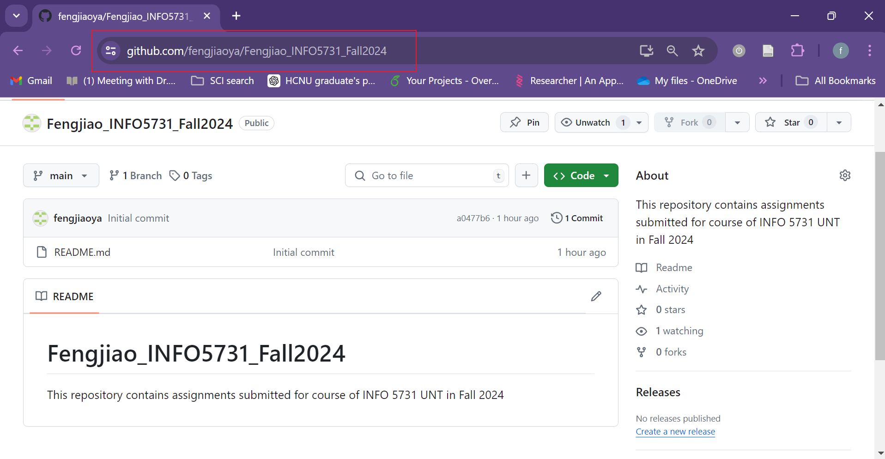
The GitHub code is publicly accessible, which means that you may find your classmates’ submissions. However, if we figure that you copy others’ code, you will certainly be given a zero, without any excuse!

